**Document Management System**

**Introduction**

Welcome to the user documentation for our Document Management system. This comprehensive guide is designed to manage files in a more convenient manner.

With our system, you can efficiently track and manage your file. This user documentation will provide you with step-by-step instructions, tips, and best practices to maximize your productivity and ensure seamless file management.

**User interface overview**

The user interface (UI) is designed to provide a user-friendly and intuitive experience, allowing you to efficiently navigate and access the system's features. Here is an overview of the key elements you will encounter within the UI:

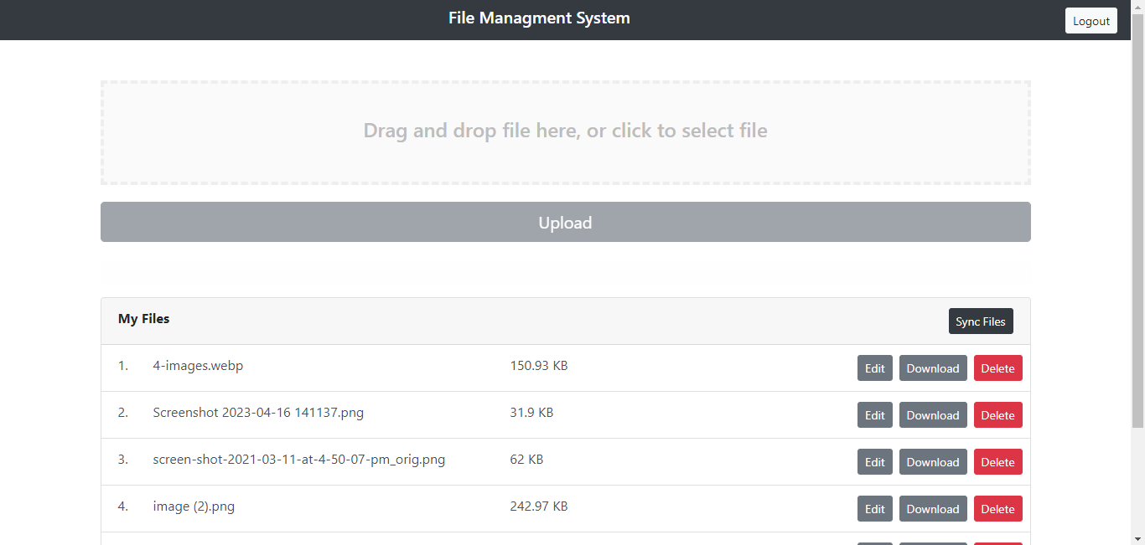

Throughout the user interface, you will commonly find buttons, icons that provide additional functionality or options. These elements are typically labeled or accompanied by tooltips to help you understand their purpose.

**Getting Started Guide**

This getting started guide will walk you through the essential tasks and workflows in our Doument Management system. By following these step-by-step instructions, you will quickly become proficient in using the system to manage your files effectively.

Logging In

* Open your preferred web browser and navigate to the login page.
* Enter your username and password if you don’t have an account you can register.
* Click the "Login" button to access the system.

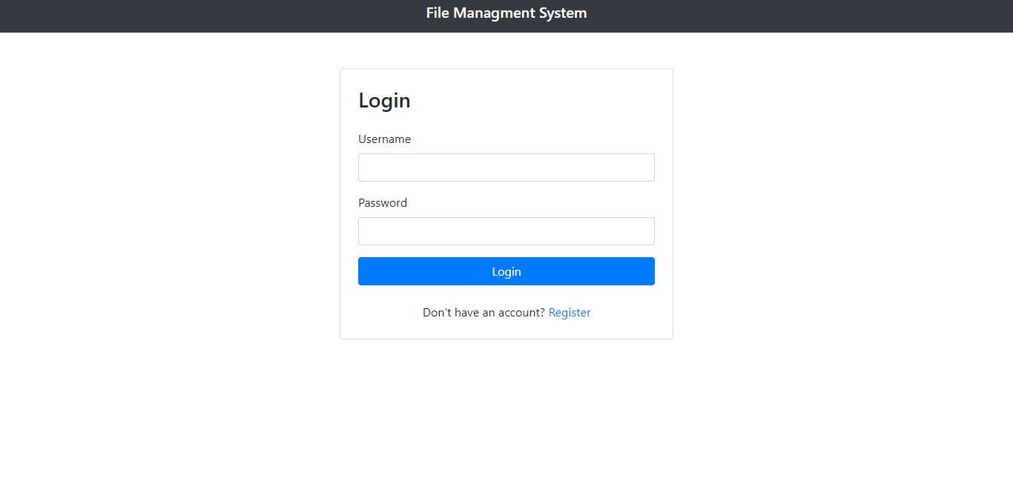

Navigating the Dashboard

* Upon logging in, you will be directed to the dashboard, which provides an overview of your files with other file management actions
* 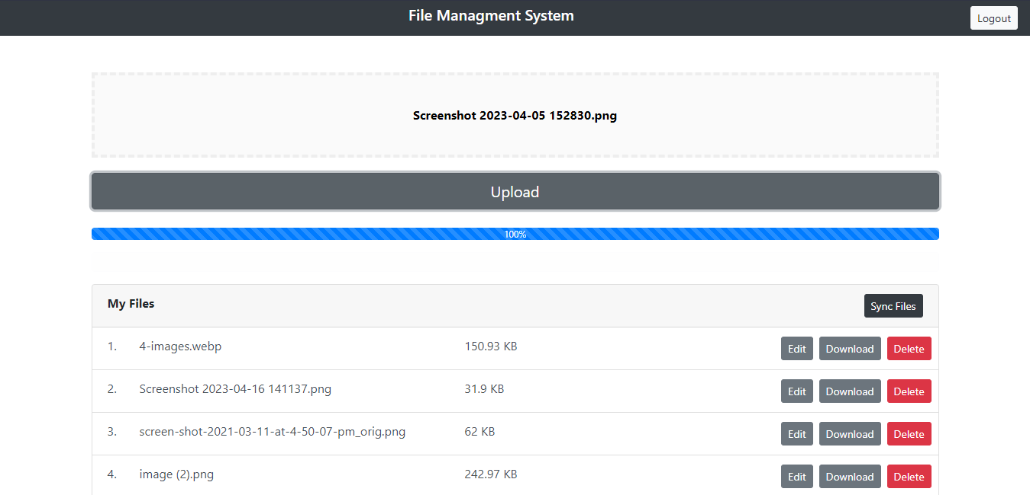Click on the different links and buttons to explore the functionality available directly from the dashboard.